Step:1   
  
Download and install the DBeaver community edition and find the below like to download

<https://dbeaver.io/files/dbeaver-ce-latest-macos-x86_64.dmg>

step 2:

Open DBeaver GUI and select the MySQL DB or PostgreSQL Database

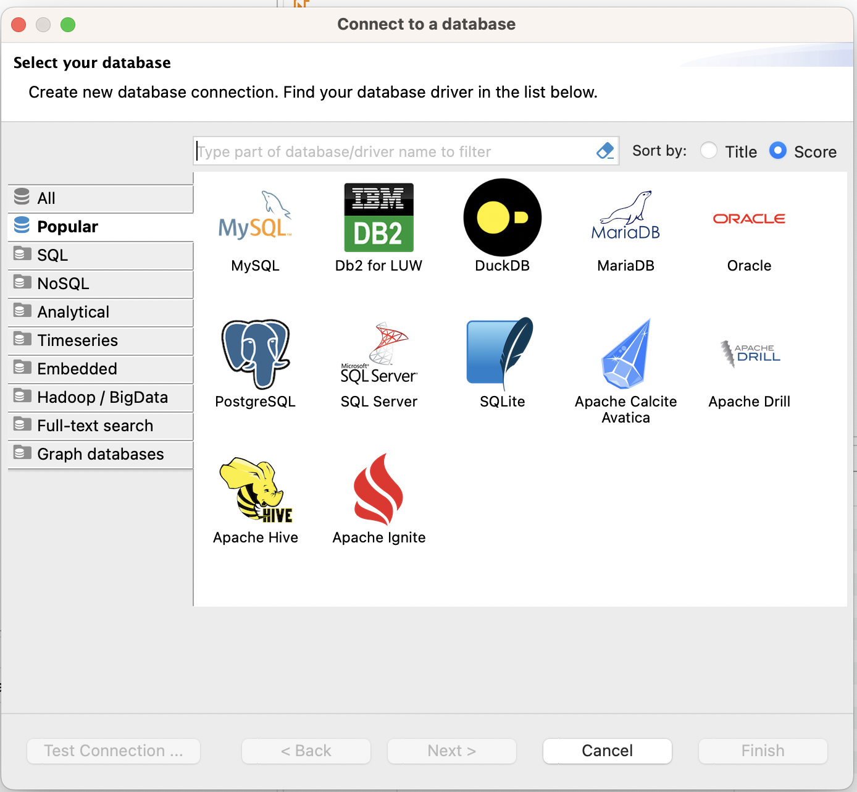

Step 3:

Enter the Database IP port and user credentials.

Step 4:

Click the Drive properties and change public key retrieval from false to true .

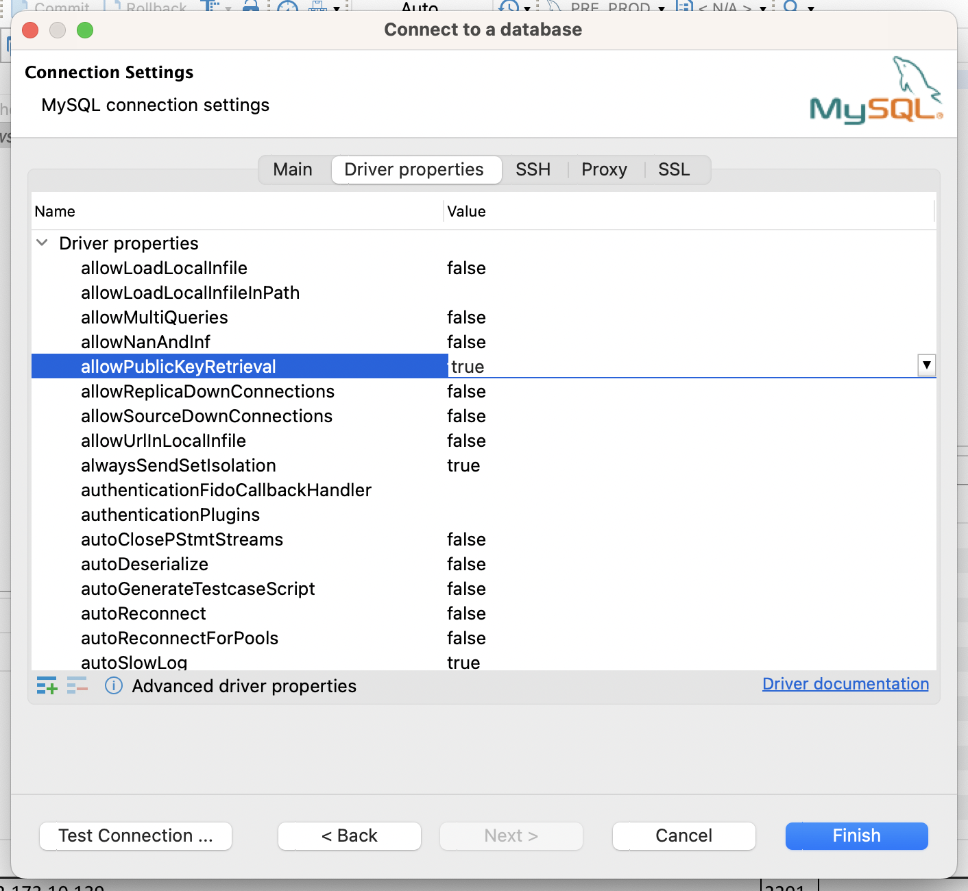

Step 5:

Click the ssh and enter the ssh tunnel details

Note:

1. Please use this jump box for prod and non prod

Prod jump IP : 172.150.0.203  
Non Prod Jump : 172.150.250.112

1. Please convert you ppk file format to OpenSSH key or use ppk file.

Step 6:

Check the test connection

